BATCH ID: **B10-4A6E**

ROLL NO: 1902050

NAME: JEEVITHA D

CODE:

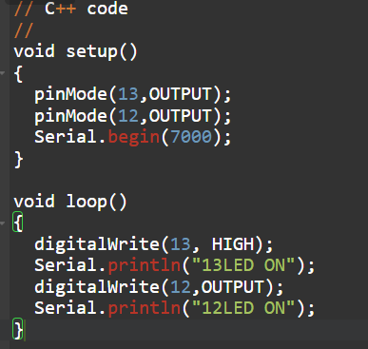

SIMULATION:

